 

Assignment - 2

|  |  |
| --- | --- |
| **Student Name/ID Number:** | Tamim Hossain |
| **Unit Number and Title:** | Database Design & Implementation |
| **Academic Year:** | 2022 |
| **Unit Assessor:** | Arvinder Kaur |
| **Project Title:** | Implementing a Database for Community Portal |
| **Issue Date:** | 28-07-2022 |
| **Submission Date:** | 31-07-2022 |
| **Internal Verifier Name:** |  |
| **Date:** | 28-07-2022 |

|  |
| --- |
| **Learner declaration** |
|  |
| I certify that the work submitted for this assignment is my own and research sources are fully acknowledged.      Student signature:  Date: 29/07/2022 |

|  |
| --- |
| **Purpose of this project** |
| **Purpose of this project**  To demonstrate your capabilities in the following areas:   * Ability to Implement a MySQL Database based on design created in Mini Project 1 |
| **Submission Format** |
| 1. Screen capture of Database Table structure in PhpMyAdmin 2. Queries used by Web pages in Tabular Format |
| **Project Brief & Guidance** |
| **Scenario:**  **Refer to the Project Scenario for the Module Project**  You have been approached by ‘ABC Jobs Pte Ltd’ as a website developer to develop a community portal for Software Developers. The project will be carried over through Module 3, Module 4, Module 5 and Capstone project. For this module the scope is to Design, Develop, Implement & Document Struts Framework Website.  The Scope of the Project is to design a Community Portal Similar to Linkedin.com. Users will be able to register in the portal using the Registration Page. Users of the portal can search for other users using various parameters such as First Name, Last Name, Company Name, City & Country. Users will be able to view the Public Profile of users after searching them. The portal allow users to login, request for forgotten password and Update their profile information  The scope of the mini project is to implement the database in MySQL.  **The overview of the project is as below**  There are 2 types of users in this Community portal. They are   1. Software Programmer 2. Administrator   **Software Programmer should be able to perform following functions in the portal**   1. Allow the programmers to register in the portal, show a thank you page & send a registration confirmation email. 2. Search & Find Other Programmers after login and view their profile. 3. Provide Login Page 4. Provide password retrieval functionality. |

|  |
| --- |
| 1. Update their Profile after logging in.   Following Functionality is part of Database Design & Will be enhanced as features as required in the Capstone Project, Depending on time availability.   1. Send Messages to Each Other on the Portal 2. Create Threads & Post Replies to a Thread 3. Post Job Opportunities in the Portal   **Administrator should be able to perform following functions in the portal**   1. Administer user data. 2. Send bulk email inviting programmers to register on the community portal   **The portal consist of the following Key pages (For Reference)**   1. Community Portal Home Page 2. Registration Page insert 3. Registration Confirmation Page 4. Update Profile Page update 5. Search Users Page select 6. List Search Results select 7. Public Profile Page select 8. Registration Confirmation Email insert 9. Login Page select 10. Forget Password Page select 11. Design the Forget Password Confirmation Page update   Following Functionality is part of Database Design and will not be part of development & Will be enhanced as features are required in the Capstone Project, Depending on time availability.   1. Send Messages insert 2. Read Messages 3. Post in Message Board 4. List Message Board 5. Read A Thread 6. Post Job Opportunities -insert 7. List Job Opportunities & Responses - select   **The scope of this assignment**  The scope is to Implement the database in MySQL   * 1. Create the tables based on design in Mini Project 1   2. Take note of Field Name, Field Type & Size   3. Implement the database in MySQL and provide screen capture   4. Create a user name in MySQL which can be used by the application, give required access privileges. (Provide screen capture of the user with access privileges)   e. Briefly list the web pages in the Community portal and queries which will be used by each of them. |

1. Create the tables based on design in Mini Project 1

|  |  |
| --- | --- |
| Entity Name | Table Name |
| **User** | * user_id **(Primary Key)** * user_name **(Foreign Key)** * user_email **(Foreign Key)** |
| **Admin** | * admin_id **(Primary Key)** * admin_name * admin_email * admin_password |
| **Bulk Email** | * bulk_email_id * bulk_email * bulk_email_type * user_id **(Foreign Key)** |
| **Log in Homepage** | * user_id **(Foreign Key)** * user_name **(Foreign Key)** * password **(Foreign Key)** |
| **Log In** | * log_in_id * user_id * email **(Foreign Key)** * password **(Foreign Key)** |
| **Registration** | * registration_id **(Primary Key)** * user_name **(Primary Key)** * email **(Primary Key)** * password **(Primary Key)** |
| **Registration Form** | * regi_id * registration_id **(Foreign Key)** * first_name * last_name * birth_day * gender * phone * country * city |
| **Profile** | * profile_id **(Primary Key)** * work_links * skills * user_id **(foreign Key)** * name * email * phone * profession |
| **Update Profile** | * Update_id * Profile_id **(Foreign Key)** |
| **Messages** | * message_id * texts * text_receiver * user_id **(Foreign Key)** * time |
| **Jobs** | * jobs_id **(Primary Key)** * company_id **(Foreign Key)** * last_date_of_application * job_position. * Salary * Admin_id **(Foreign Key)** |
| **Jobs response** | * jobs_resp_id * jobs_id **(Foreign Key)** * user_id **(Foreign Key)** |
| **Company** | * company_id **(Primary Key)** * company_name * address * location * website_link * contact |

1. Take note of Field Name, Field Type & Size

|  |  |
| --- | --- |
| Entity Name | Table Name |
| User | user_tbl   |  |  |  | | --- | --- | --- | | Field Name | Field Type | Size | | user_id | int | 11(PK) | | registration_id | int | 11(FK) | | user_name | Varchar | 200 | | user_email | Varchar | 320 | |
| Admin | admin_tbl   |  |  |  | | --- | --- | --- | | Field Name | Field Type | Size | | admin_id | int | 11(PK) | | admin_name | Varchar | 200 | | admin_email | Varchar | 320 | | admin_password | varchar | 256 | |
| Bulk Email | bulk_email_tbl   |  |  |  | | --- | --- | --- | | Field Name | Field Type | Size | | Bulk Email_ID | int | 11 | | Bulk Email | Text | 65535 | | Bulk Email Type | Varchar | 320 | | User_id | int | 11(FK) | |
| Log In Homepage | Log_in_homepage_tbl   |  |  |  | | --- | --- | --- | | Field Name | Field Type | Size | | Log_in_hm_id | int | 11 | | user_id | int | 11(FK) | | user_name | Varchar | 200 | | password | varchar | 256 | |
| Log In | log_in_tbl   |  |  |  | | --- | --- | --- | | Field Name | Field Type | Size | | log_in_id | int | 11 | | user_id | int | 11(FK) | | Email | Varchar | 320 | | password | varchar | 256 | |
| Registration | registration_tbl   |  |  |  | | --- | --- | --- | | Field Name | Field Type | Size | | registration_id | int | 11(PK) | | User_name | Varchar | 200 | | Email | Varchar | 320 | | password | varchar | 256 | |
| Registration Form | registration_form_Tbl   |  |  |  | | --- | --- | --- | | Field Name | Field Type | Size | | regi_id | int | 11 | | registration_id | int | 11(FK) | | first_name | varchar | 64 | | last_name | varchar | 64 | | birth_day | Date |  | | Gender | Varchar | 15 | | Phone | Varchar | 15 | | country | Varchar | 100 | | City | Varchar | 100 | |
| Profile | Profile_tbl   |  |  |  | | --- | --- | --- | | Field Name | Field Type | Size | | profile_id | int | 11(PK) | | work_links | blob | 256 | | Skills | varchar | 256 | | user_id | int | 11 (FK) | | Name | varchar | 64 | | Email | varchar | 256 | | Phone | varchar | 15 | | profession | varchar | 256 | | photo | blob |  | |
| Update profile | update_profile_tbl   |  |  |  | | --- | --- | --- | | Field Name | Field type | Size | | Update_id | int | 11 | | profile_id | int | 11(FK) | |
| Messages | messages_tbl   |  |  |  | | --- | --- | --- | | Field Name | Field Type | Size | | messages_id | int | 11 | | Text | text | 65535 | | text_reciver | Varchar | 128 | | User_id | int | 11(FK) | | time | int | 11 | |
| Jobs | jobs_tbl   |  |  |  | | --- | --- | --- | | Field Name | Field Type | Size | | jobs_id | int | 11(PK) | | company_id | int | 11(FK) | | deadline_of_application | date |  | | job_position | varchar | 50 | | salary | int | 11 | | admin_id | int | 11(FK) | |
| Jobs response | Jobs_resp_tbl   |  |  |  | | --- | --- | --- | | Field Name | Field Type | Size | | jobs_resp_id | int | 11 | | Jods_id | int | 11 (FK) | | User_id | Int | 11(FK) | |
| Company | company_tbl   |  |  |  | | --- | --- | --- | | Field Name | Field Type | Size | | company_id | int | 11(pk) | | company_name | varchar | 250 | | address | varchar | 250 | | location | Varchar | 250 | | website_link | blob |  | | contact | Varchar | 15 | |

1. Implement the database in MySQL and provide screen capture

**Creating DATABASE**

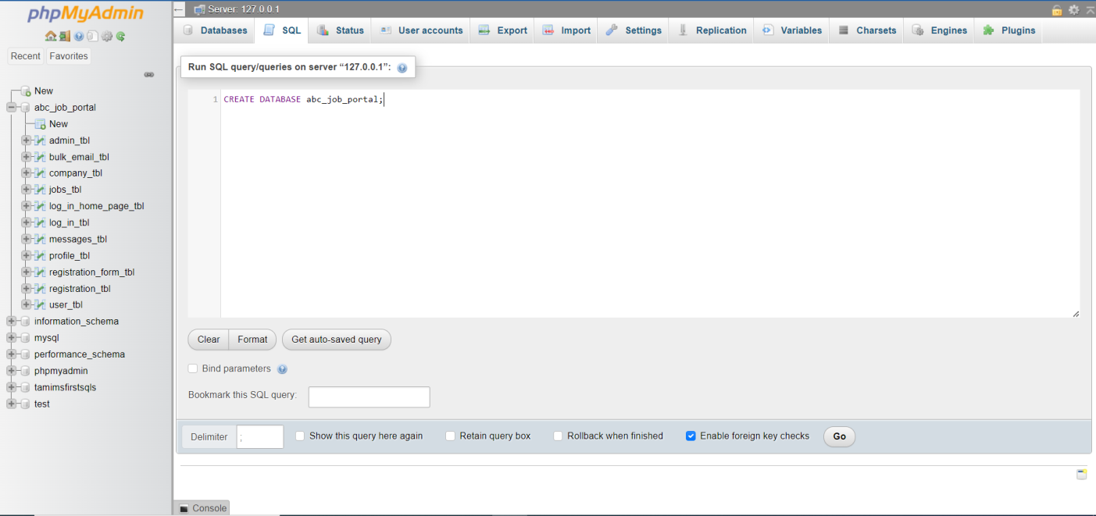

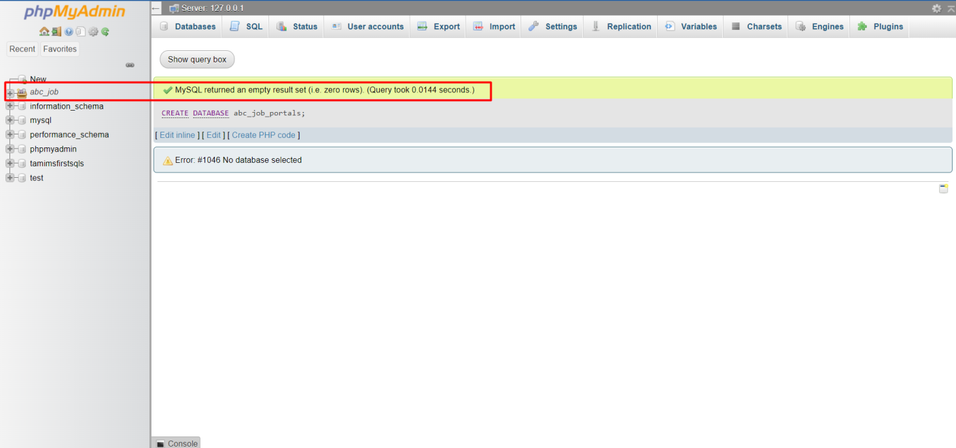

Creating Table

**Admin Table**

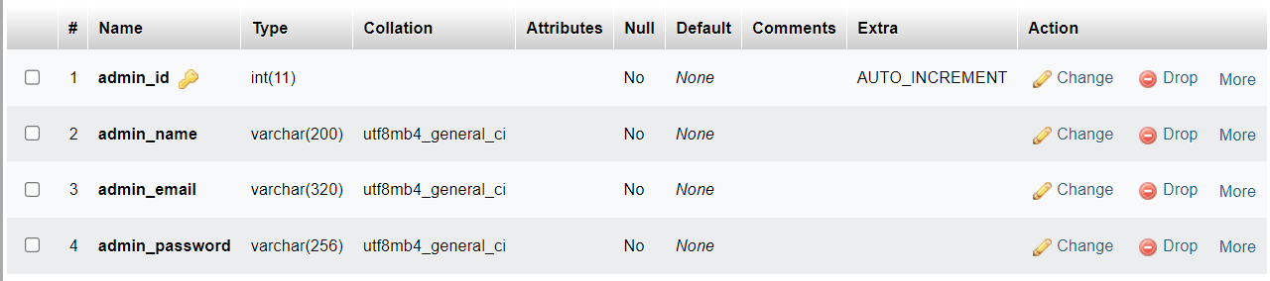

**Bulk email Table**

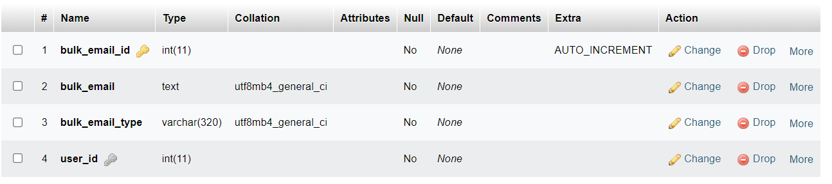

**Company Table**

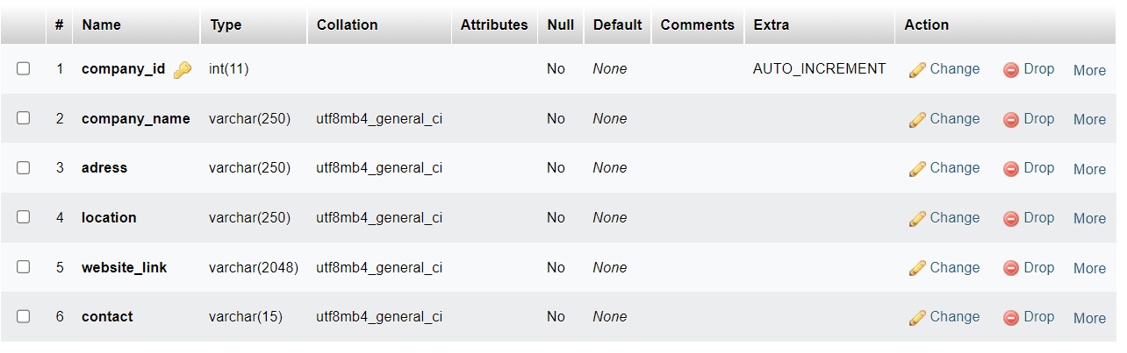

**Job Response Table**

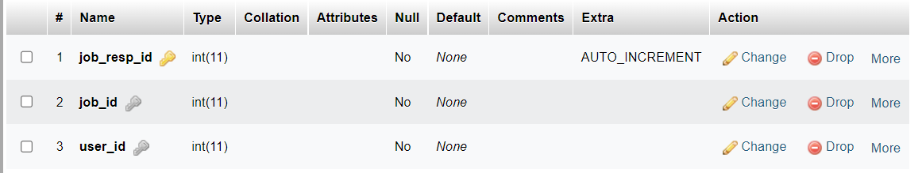

**Jobs Table**

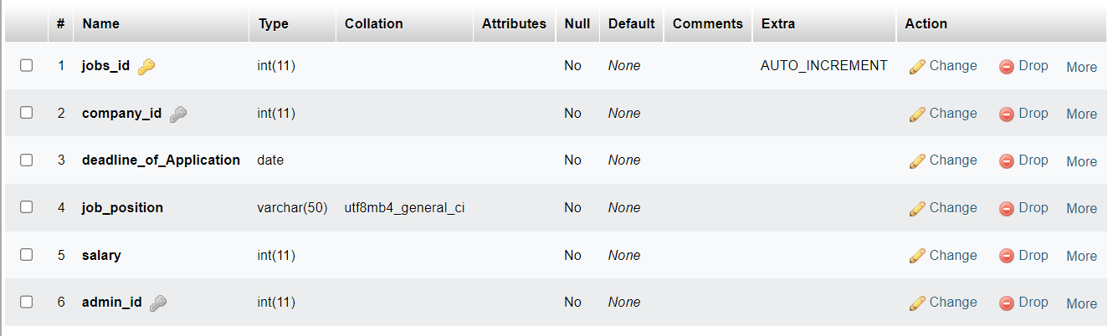

**Log In Home page Table**

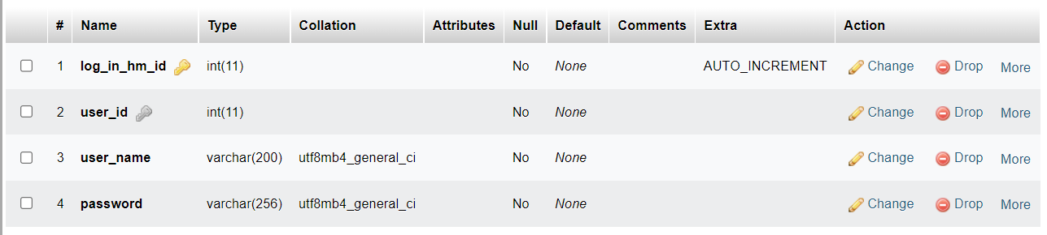

**Log In table**

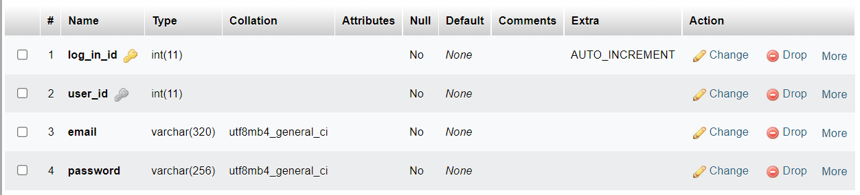

**Messages Table**

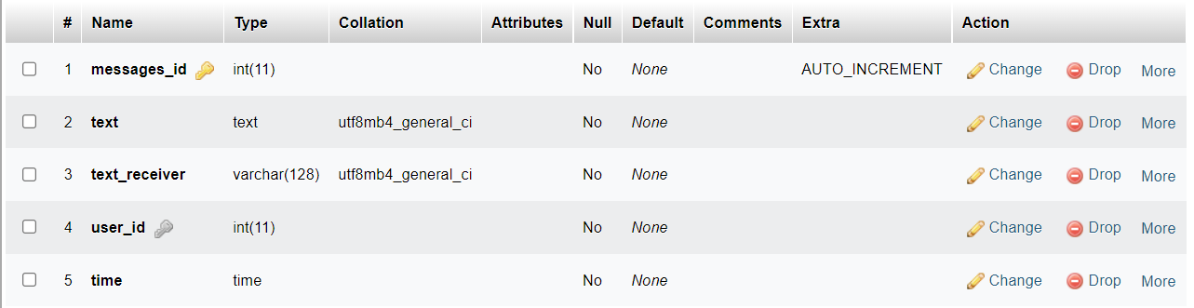

**Profile Table**

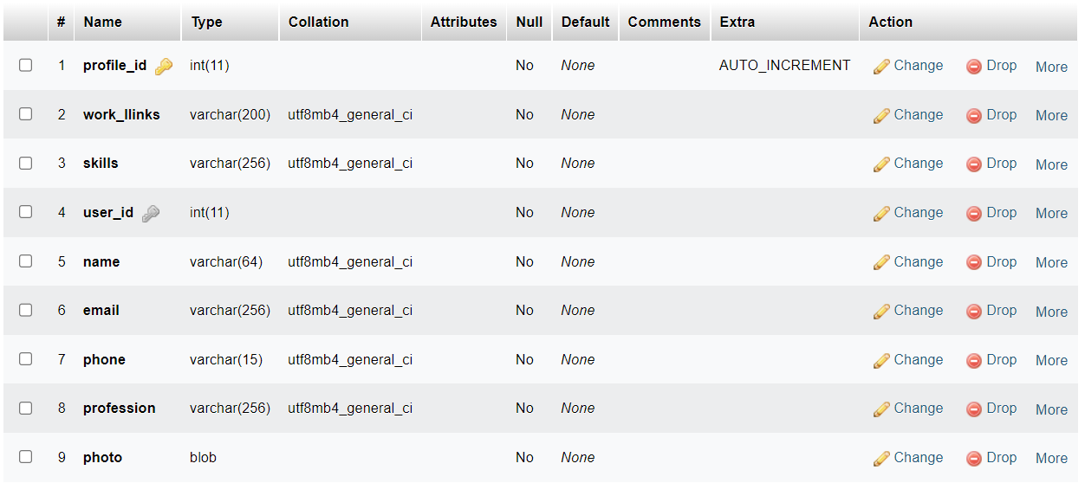

**Registration Form Table**

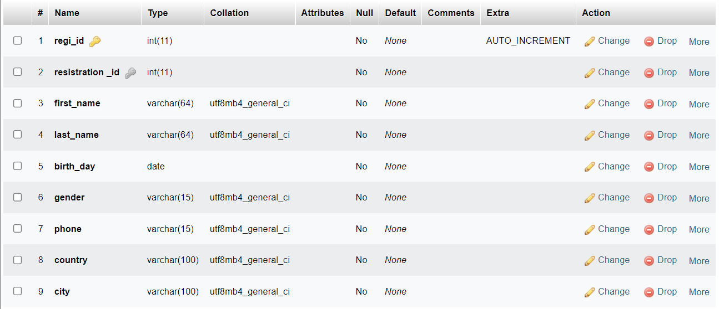

**Update profile Table**

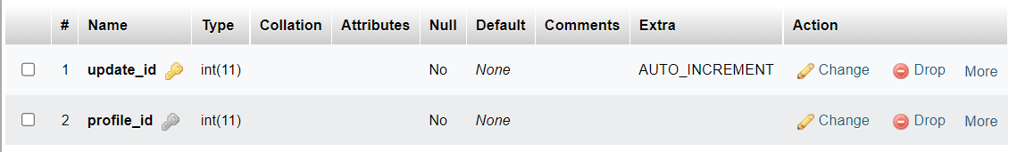

**User Table**

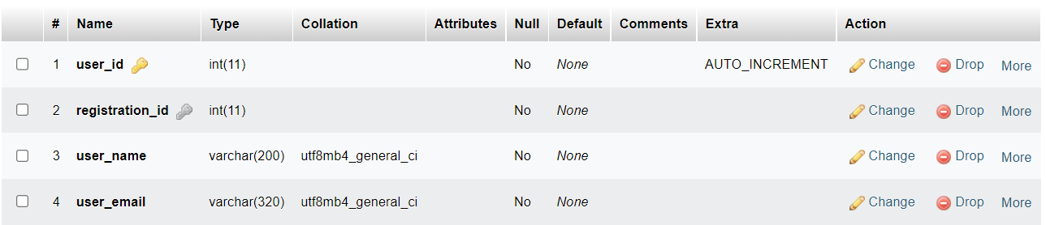

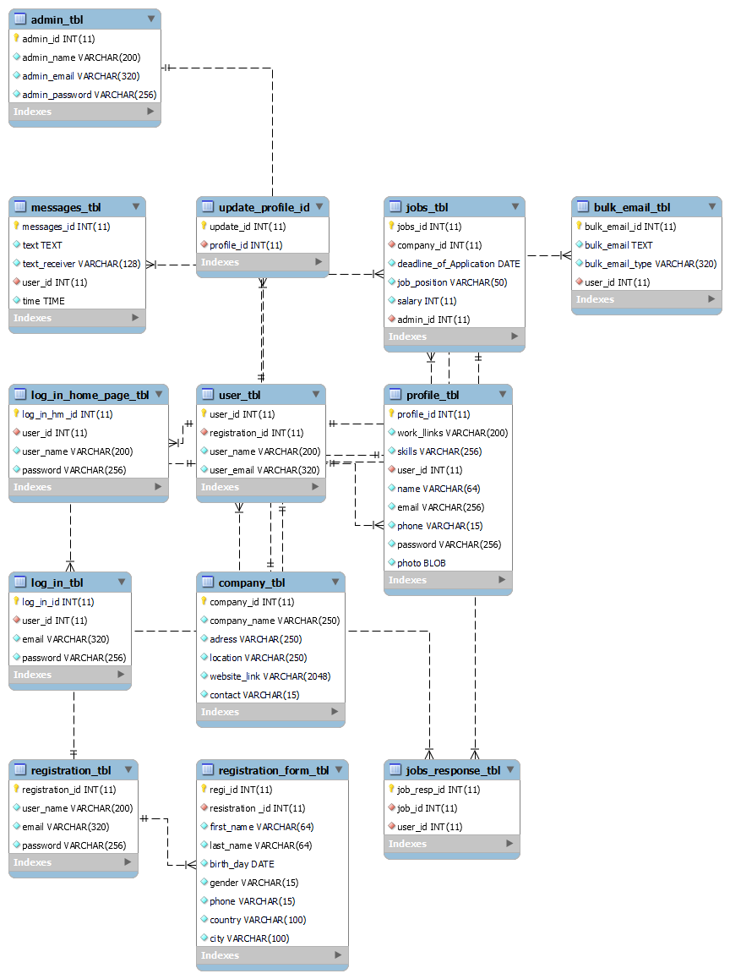

1. Create a user name in MySQL which can be used by the application, give required access privileges. (Provide screen capture of the user with access privileges)

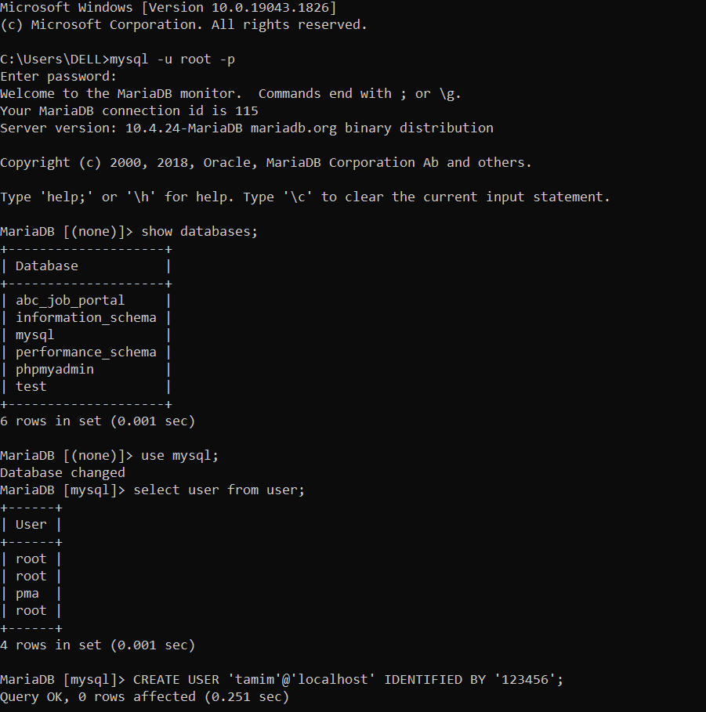

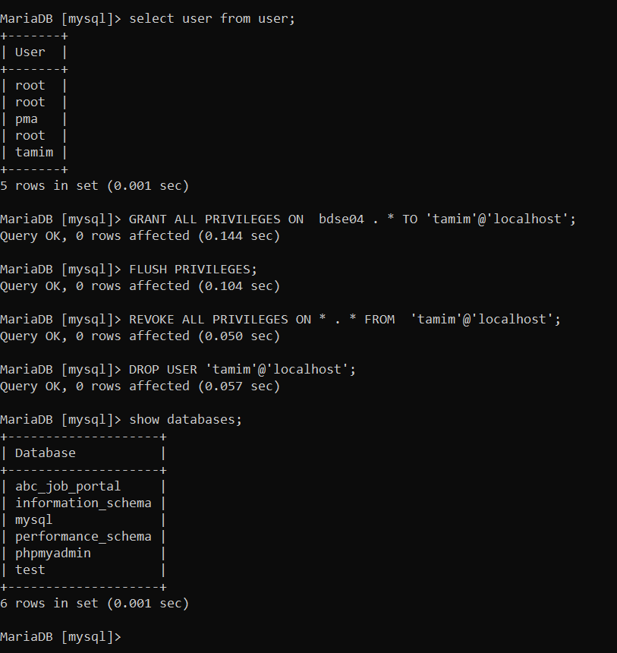

1. Briefly list the web pages in the Community portal and queries which will be used by each of them.

|  |  |  |
| --- | --- | --- |
| sno | Page Name | Query |
| 1 | Admin | INSERT INTO `admin_tbl` (`admin_id`, `admin_name`, `admin_email`, `admin_password`) VALUES  (1, 'Shudipto Hasan', 'Khaledkhan32@gmail.com', '112233Sudipto+'),  (2, 'Sudipto chanda Niloy', 'sdp32548@gmail.com', 'Dipto12345roxx'),  (3, 'Akib Al Tanin', 'Akibaltanin42@gmail.com', 'vuti987654-=+'),  (4, 'Masum Ahmed', 'mahmed3215@gmail.com', 'master-masum21356'); |
| 2 | Bulk Email | INSERT INTO `bulk_email_tbl` (`bulk_email_id`, `bulk_email`, `bulk_email_type`, `user_id`) VALUES  (1, 'Register with Abc Job portal. To register, fill out the personal details requested on the registration form and submit by clicking on “Sign Up.” An account is automatically created, and the user can create a marketing email campaign.\r\nHere we are offering u something you might like', 'Promotional ', 1),  (2, 'Register with SendPulse. To register, fill out the personal details requested on the registration form and submit by clicking on “Sign Up.” An account is automatically created, and the user can create a marketing email campaign.', 'Promotional', 2),  (3, 'Thank you for your registration in ABC job portal here you will find a link use that to give your external details...\r\nThen simply log in...\r\nWelcome to ABC Job portal', 'registration', 3),  (4, 'Welcome To ABC job portal hope your upcoming days will go well with us...\r\nHere you will find the news latter\r\nKindly please refer this and explain us your choice of interest', 'Newsletter', 4); |
| 3 | Company | INSERT INTO `company_tbl` (`company_id`, `company_name`, `adress`, `location`, `website_link`, `contact`) VALUES  (1, 'Oracle.com', 'brooklyn,NY state. NY', 'Hampson Rever,1234 street lake view park', 'https://www.oracle.com', '+8801716605265'),  (2, 'google.com', 'California State.CF', 'Lake view park ,$325 road ', 'www.google.com', '+96340988234734'),  (3, 'Unsplash.com', 'Copenhegen,Denmark', 'Lylen street,23 criest charce ', 'https://unsplash.com/s/photos/study', '+78786565765'),  (4, 'Git Hub', 'Cape Town,Australia', 'river side port cleopetry', 'https://github.com', '+9875463225'); |
| 4 | Job Response | INSERT INTO `jobs_response_tbl` (`job_resp_id`, `job_id`, `user_id`) VALUES  (1, 1, 1),  (2, 2, 2),  (3, 3, 3),  (4, 4, 4); |
| 5 | Jobs | INSERT INTO `jobs_tbl` (`jobs_id`, `company_id`, `deadline_of_Application`, `job_position`, `salary`, `admin_id`) VALUES  (1, 1, '2022-07-07', 'Software developer', 1400, 1),  (2, 2, '2022-07-02', 'Full stack developer ', 1500, 2),  (3, 3, '2022-07-02', 'Front end developer', 1100, 3),  (4, 4, '2022-07-31', 'Back end Developer', 1200, 4); |
| 6 | Log in homepage | INSERT INTO `log_in_home_page_tbl` (`log_in_hm_id`, `user_id`, `user_name`, `password`) VALUES  (1, 1, 'Afnan_sayed4234', '3674398786TYv'),  (2, 2, 'rimaislam98', '3867368394654,jkjyfthdgf'),  (3, 3, 'gazifr6590', 'aisuidysj988'),  (4, 4, 'AngryQueen100', 'l;klkhjgh87978'); |
| 7 | Log in | INSERT INTO `log_in_tbl` (`log_in_id`, `user_id`, `email`, `password`) VALUES  (1, 1, 'asayed0245126@hmail.com', '3678867465kj'),  (2, 2, 'aQ@koutlook@com', 'lkkjhg76it5'),  (3, 3, 'Gfra0982hmail.com', '3699886jhsghjhs'),  (4, 4, 'rms@gmail.com', 'jkhjmghfg98'); |
| 8 | Messages | INSERT INTO `messages_tbl` (`messages_id`, `text`, `text_receiver`, `user_id`, `time`) VALUES  (2, 'Hola, comment allez, allez-vous?\r\nSo nice to meet ya\r\nYou say we should go and get a room (no)\r\nIf you wanna turn it on\r\nGo, get a lightbulb, después hablamos\r\nIf you wanna turn it on\r\nGo, get a lighter, después bailamos\r\nOh, un, dos, tres\r\nUn, dos, tres\r\nSi te doy un beso ya estás a mis pies\r\nDime un, dos, tres\r\nUn, dos, tres\r\nLa, la, la, la, la', 'hacker4321', 1, '08:31:25'),  (3, 'Hola, comment allez, allez-vous?\r\nSo nice to meet ya\r\nYou say we should go and get a room (no)\r\nIf you wanna turn it on\r\nGo, get a lightbulb, después hablamos\r\nIf you wanna turn it on\r\nGo, get a lighter, después bailamos\r\nOh, un, dos, tres\r\nUn, dos, tres\r\nSi te doy un beso ya estás a mis pies\r\nDime un, dos, tres\r\nUn, dos, tres\r\nLa, la, la, la, la', 'nackopl89', 2, '16:00:00'),  (4, 'Hola, comment allez, allez-vous?\r\nSo nice to meet ya\r\nYou say we should go and get a room (no)\r\nIf you wanna turn it on\r\nGo, get a lightbulb, después hablamos\r\nIf you wanna turn it on\r\nGo, get a lighter, después bailamos\r\nOh, un, dos, tres\r\nUn, dos, tres\r\nSi te doy un beso ya estás a mis pies\r\nDime un, dos, tres\r\nUn, dos, tres\r\nLa, la, la, la, la', 'lopreshiko2356', 3, '21:47:18'),  (5, 'Hola, comment allez, allez-vous?\r\nSo nice to meet ya\r\nYou say we should go and get a room (no)\r\nIf you wanna turn it on\r\nGo, get a lightbulb, después hablamos\r\nIf you wanna turn it on\r\nGo, get a lighter, después bailamos\r\nOh, un, dos, tres\r\nUn, dos, tres\r\nSi te doy un beso ya estás a mis pies\r\nDime un, dos, tres\r\nUn, dos, tres\r\nLa, la, la, la, la', 'lpredsergei23', 4, '05:22:09'); |
| 9 | Profile | INSERT INTO `profile_tbl` (`profile_id`, `work_llinks`, `skills`, `user_id`, `name`, `email`, `phone`, `profession`, `photo`) VALUES  (1, 'google.com', 'Software_developer', 1, 'Afnan Sayed', 'Afs@hotmail.com', '+880015698656', 'Former Software Engineer Oracle', |
| 10 | Registration form | INSERT INTO `registration_form_tbl` (`regi_id`, `resistration _id`, `first_name`, `last_name`, `birth_day`, `gender`, `phone`, `country`, `city`) VALUES  (1, 1, 'Tamim', 'Hossain', '2012-07-01', 'Male', '+8801716605', 'Bangladesh', 'Chandpur'),  (2, 2, 'Any', 'One', '2012-07-05', 'Female', '+098765432', 'India', 'punjab'),  (3, 3, 'No ', 'One', '2022-07-01', 'Female', '+896541223655', 'canada', 'Toronto'),  (4, 4, 'Hasaranga', 'Wanindu', '2022-07-01', 'Male', '+056987452', 'Sri Lanka', 'Bandarawela'); |
| 11 | Registration | INSERT INTO `registration_tbl` (`registration_id`, `user_name`, `email`, `password`) VALUES  (1, 'Afnan_Sayed4234', 'afsayed65@hotmail.com', '654654655'),  (2, 'anyone908', 'a94@gmail.com', '635346646an94'),  (3, 'noOne98', 'no098@gmail.com', '3545648noahg'),  (4, 'hasarfanga65898', 'hfaranga54@hotmail.com', 'typhoon6578'); |
| 12 | Update Profile | INSERT INTO `update_profile_tbl` (`update_id`, `profile_id`) VALUES  (3, 1),  (4, 2),  (2, 3),  (1, 4); |
| 13 | User | INSERT INTO `user_tbl` (`user_id`, `registration_id`, `user_name`, `user_email`) VALUES  (1, 1, 'Afnan_sayed4234', 'afsayed65@hotmail.com'),  (2, 2, 'rimaislam98', 'rimaislam1@outlook.com'),  (3, 3, 'gazifr6590', 'gazifariya43@protonmail.com'),  (4, 4, 'AngryQueen100', 'aqueen98@hotmail.com'); |